Assignment Day 3

**Task 1 : expected time -20 Minutes( Filters and Parameters)**

**Note : Open a New workbook and use data source : c:/data/tableau session/global superstore 2016.xlsx, order table, design of the sheet is as per your choice(background color, sheetname,font size etc.)**

1. Design a sheet called ‘ top cun’ showing top 5 countries as per profit in form of bar chart.
2. Design another sheet with same filter ( use filter of top cun sheet) and display segment and category( use Hierarchy ) wise sales as crosstab.
3. Design another sheet for top N data( customer name,sales) and allow user to decide value of N at run time.(Hint:Parameters)
4. Design a sheet using Subacategory and Sales(use bubble chart) for all subcategories except Chairs,Accessories and Labels
5. Design a sheet using to display Category wise data showing sales and profit ( use scatter plot), there should be two interactive filters : Category and subacategory. When u select a value in category, then the sabcategory filter should show values of that category only, for example : if u select Furniture then the sabcategory filter should display Chair,table,bookcases etc only.

Save this workbook as ‘Filters_dates .twbx’

**Task 2 : Working with Dates (20 Minutes)**

Keep working in ‘Filters_dates.twbx’ workbook.

1. Add a new sheet name it as Date filter, use orderdate and Sales( line chart) . Print qtr wise sales( 2012 Q1), there should be sales values printed in chart. Ensure the data is display for dates between 10 October 2012 to 10 October 2014 only.
2. Design Something like below : where per day sales is displayed , display it only for year 2012.

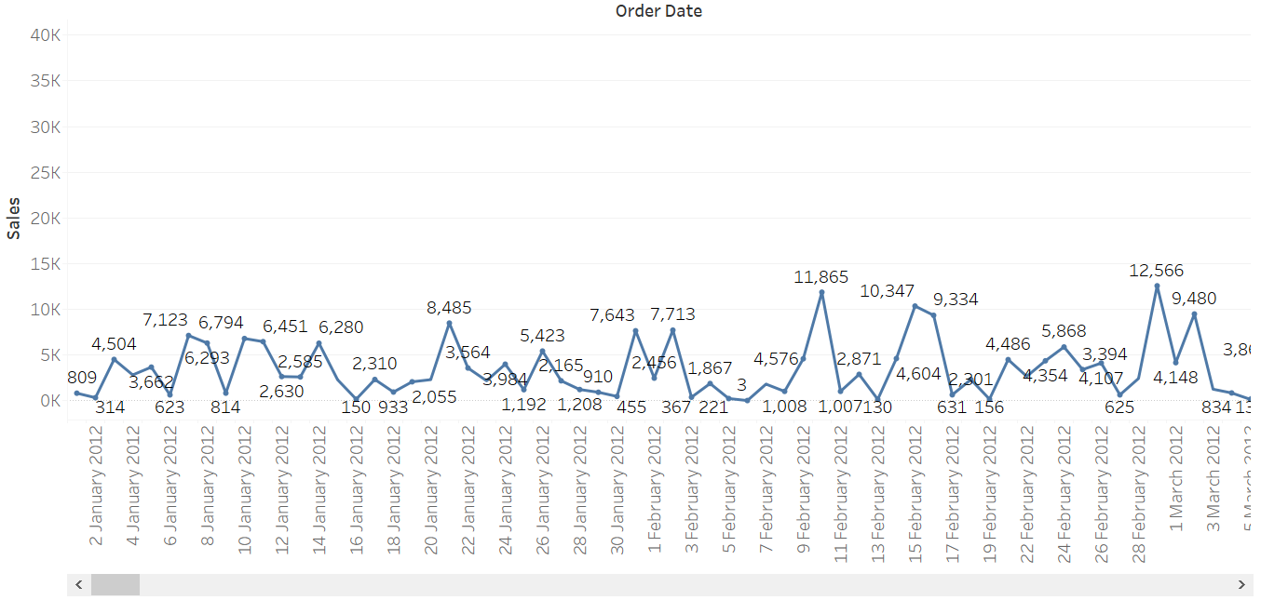

1. Assume that the Financial Year start from 01 June in your country. Make this setting in your data and display like below :

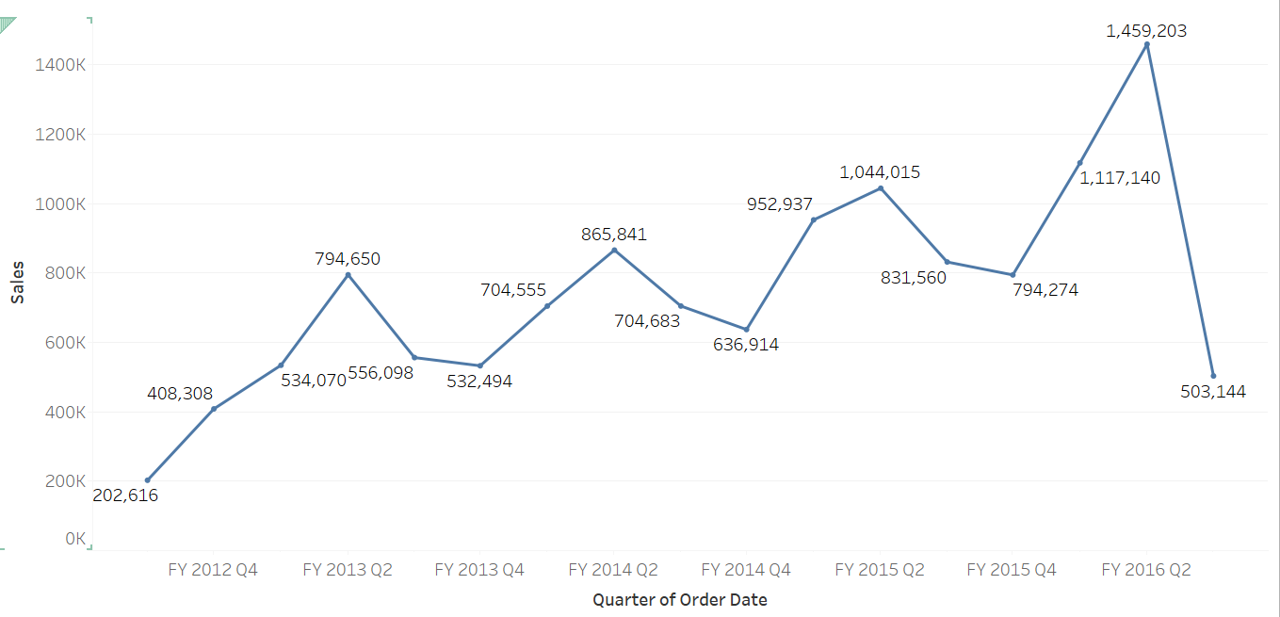

Save the workbook an close it.

Task3 : 20 Minutes

Open a new Tableau workbook and connect to C:/data/Tableau session/Global Superstore 2016.xlsx. Select orders as your table by dragging it on to work area.

1. Design sheet1 using category , subcategory and sales. Draw a reference line to highlight plot area between minimum sales to average sales.
2. Duplicate sheet1 and rename new sheet as target, remove reference line, add a custom reference line with value of 500000 and find out how many subcat has earned more than this target and fill that area with light green color

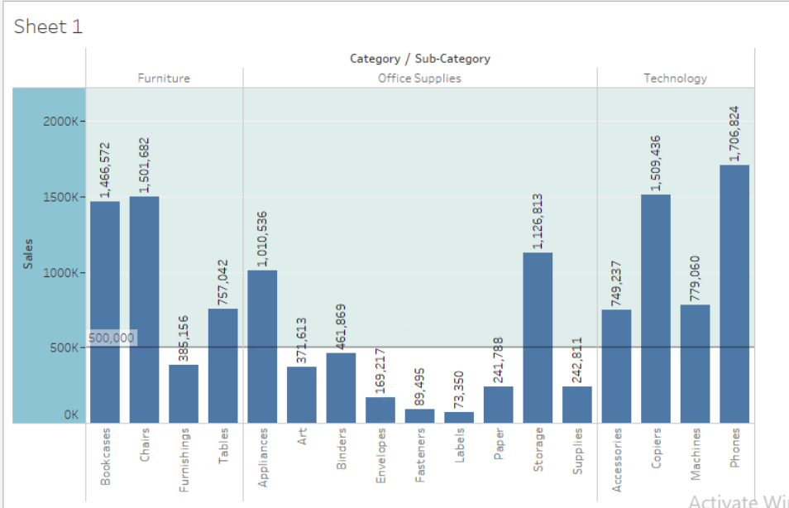

3 Design a new sheet with orderdate and sales, draw a line in chart for the date 14-april-2014 , it will help you to see your performance before and after this date, it will act like a breaking point.

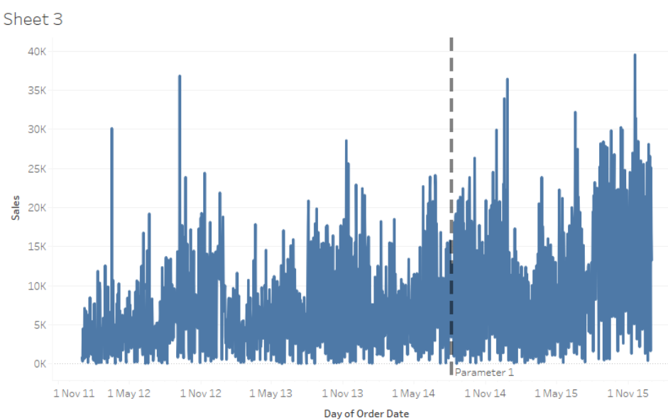

Task 4 :20 minutes

Open a new Tableau workbook and connect to C:/data/Tableau session/Global Superstore 2016.xlsx. Select orders as your table by dragging it on to work area.

1. On sheet1 design a Funnel chart showing Market and sales

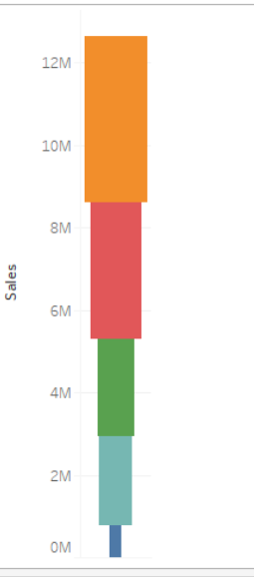

1. On Sheet2 , find out Rank of Subcategory over years.

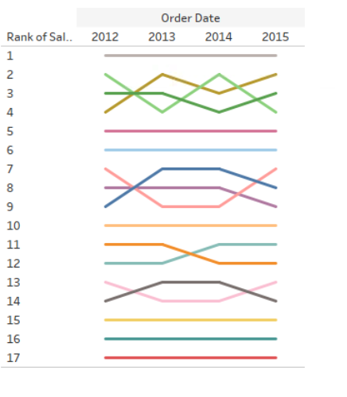

1. On Sheet 3 draw a scatter chart to find out outlier countries in gaining profit and sales. We should able to analyze it per year basis
2. 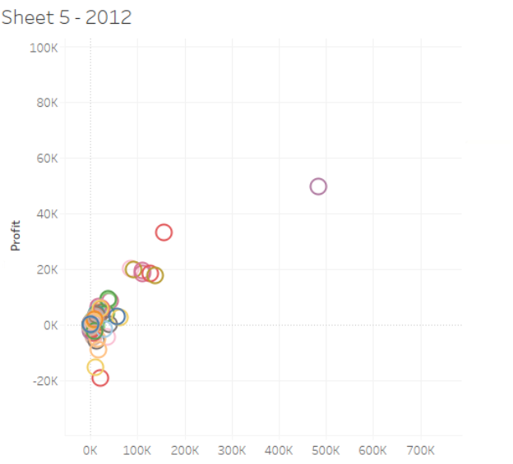

Save it as misc.twbx